Linux Administration Essenstials
Assignment 1 Day 3
1. Create a blank file named “myfile”

To create a blank file we use the command touch( the name of the file) as shown in on the picture below:
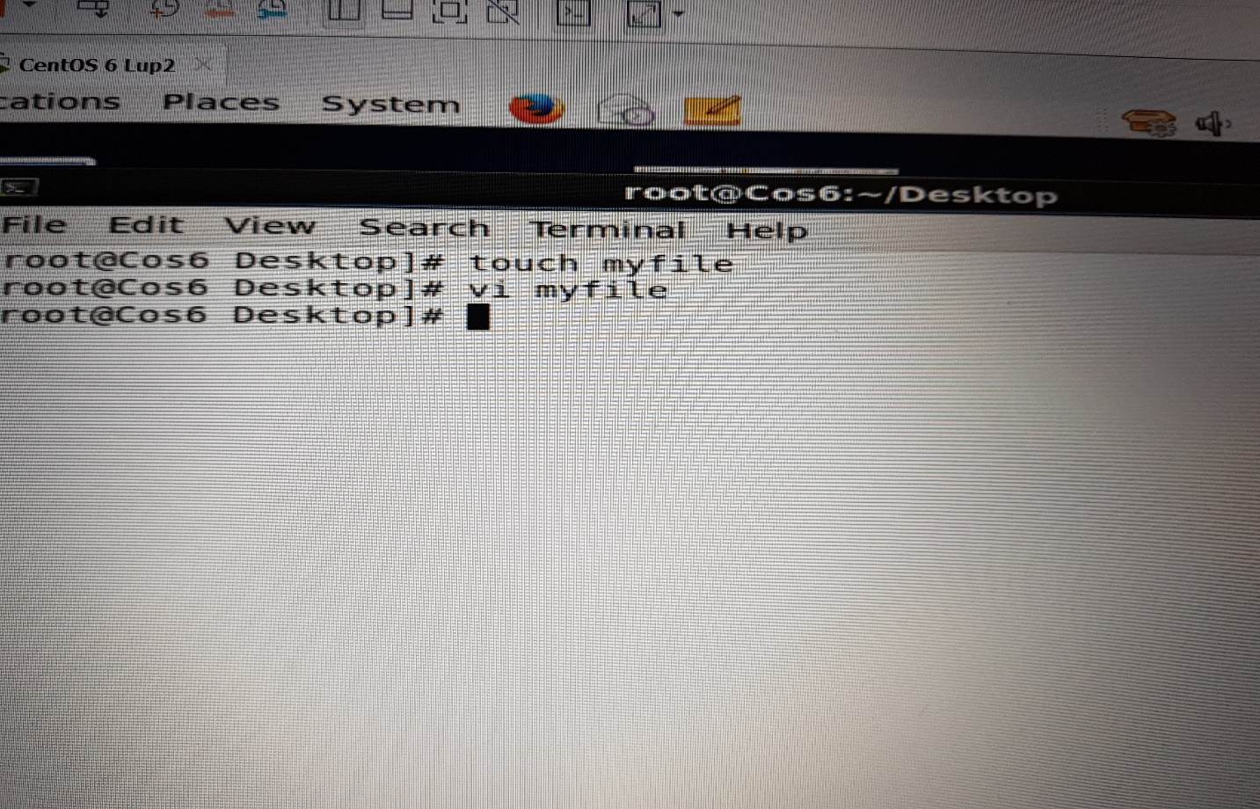

2. Open “myfile” in a vi editor
To open the file in vi editor, we use command vi (name of file) in this case . Its vi myfile then press enter then get the page as shown in the diagram below:

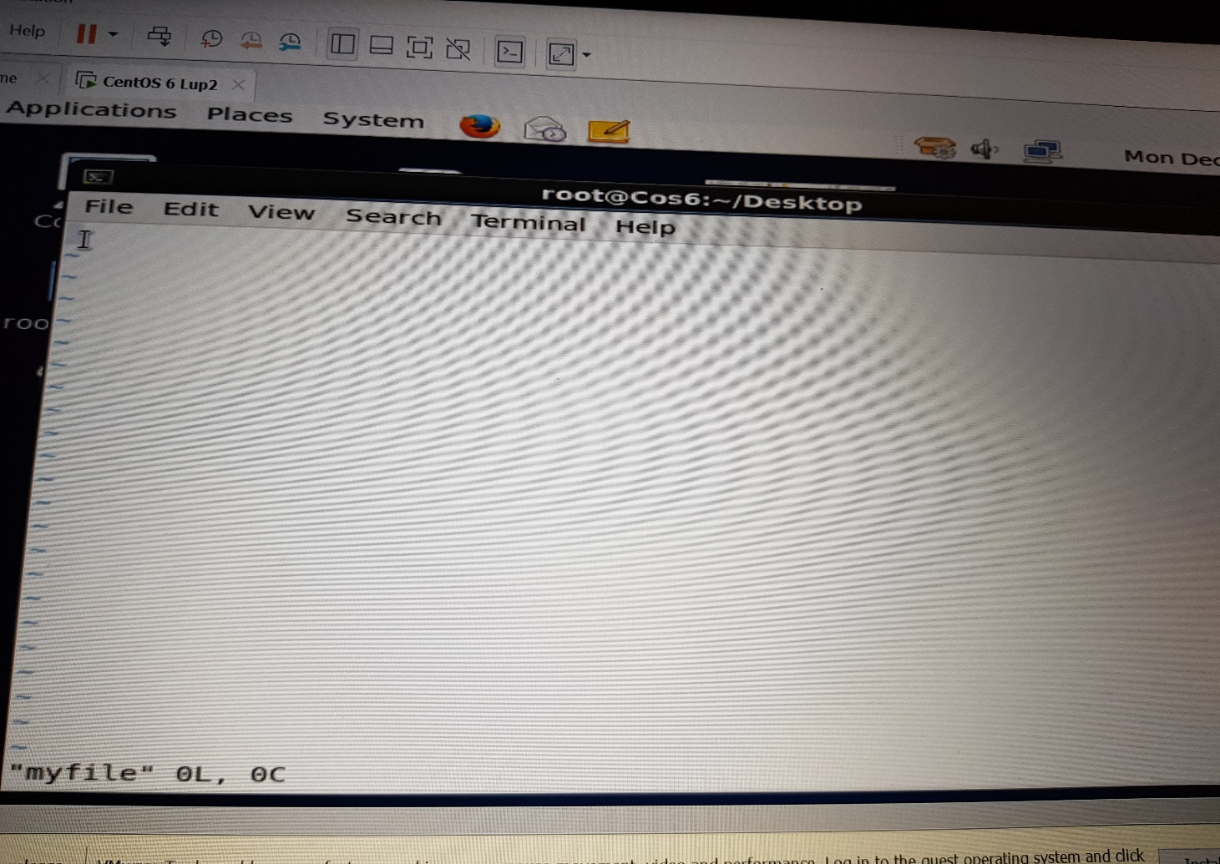

3. Write your name, address, email id, phone number and blood group in 5 different lines
In order to write on the vi editor, press I there after enter the details as shown on the diagram:
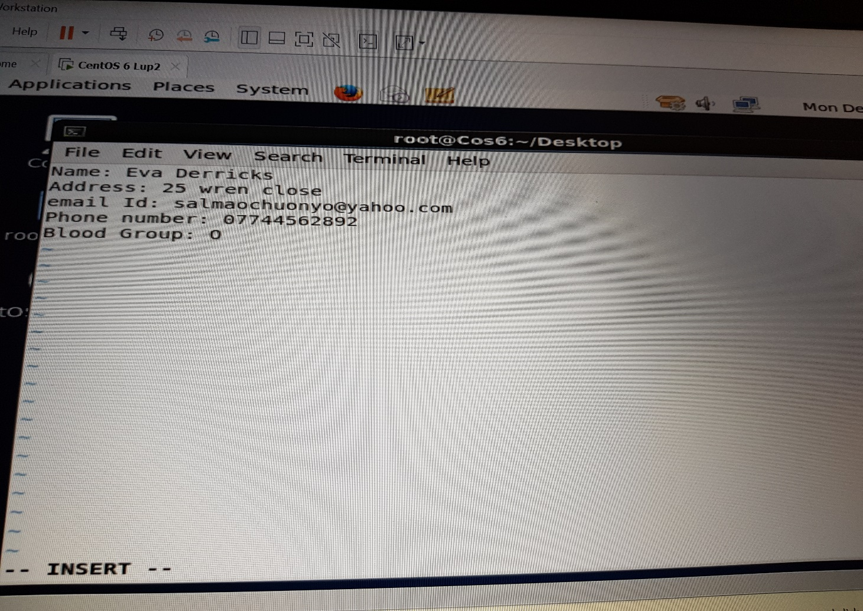

4. Build one single expression to see the line with your name and blood group.
We use the command head -n name of the file | tail -n
As shown below:
